ST10291856 Database Class Activity

CREATE DATABASE ACCOMMODATION;

CREATE TABLE CUSTOMERS(

CUSTOMER_ID VARCHAR(10) NOT NULL PRIMARY KEY,

CUSTOMER_NAME VARCHAR(50) NOT NULL

);

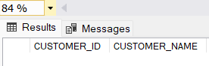

CREATE TABLE VENUES(

VENUE_CODE VARCHAR(5) NOT NULL PRIMARY KEY,

VENUE_NAME VARCHAR(50) NOT NULL,

ADDRESS VARCHAR(50) NOT NULL,

CITY VARCHAR(50) NOT NULL

);

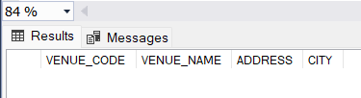

CREATE TABLE ACCOMMODATION_BOOKINGS(

CUSTOMER_ID VARCHAR(10) NOT NULL,

VENUE_CODE VARCHAR(5) NOT NULL,

CHECKIN_DATE DATE NOT NULL,

NIGHTS SMALLINT NOT NULL,

RATE SMALLMONEY NOT NULL,

FOREIGN KEY (CUSTOMER_ID) REFERENCES

CUSTOMERS(CUSTOMER_ID),

FOREIGN KEY (VENUE_CODE) REFERENCES

VENUES(VENUE_CODE)

);

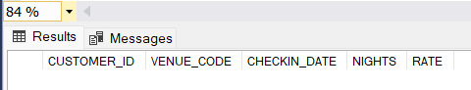

INSERT INTO CUSTOMERS

VALUES

('123456', 'Neo Petlele'),

('246810', 'Derek Moore'),

('369121', 'Pedro Ntaba'),

('654321', 'Thabo Joe'),

('987654', 'Dominique Woolridge');

INSERT INTO VENUES

VALUES

('V0001', 'Durbs Bed and Breakfast', '12 Radar Drive', 'Durban'),

('V0002', 'Jacaranda Guesthouse', '116 Clearwater Road', 'Pretoria'),

('V0003', 'Sandton Sun', '1 Waterstone Drive', 'Sandton'),

('V0004', 'Friendly City Hotel', '2 Ring Road', 'Port Elizabeth'),

('V0005', 'Belmont Self Catering', '1 Belmont Road', 'Cape Town');

INSERT INTO ACCOMMODATION_BOOKINGS

VALUES

('123456', 'V0001', '2020‐10‐30', '3', '1500.00'),

('246810', 'V0005', '2020‐11‐19', '2', '980.00'),

('246810', 'V0004', '2020‐10‐15', '5', '1100.00'),

('654321', 'V0002', '2020‐09‐10', '1', '1350.00'),

('987654', 'V0001', '2020‐12‐15', '7', '1300.00'),

('123456', 'V0002', '2020‐11‐01', '3', '1350.00'),

('246810', 'V0003', '2020‐09‐29', '4', '2100.00');

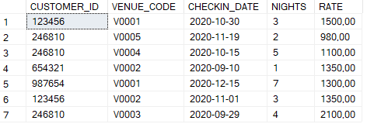

ALTER TABLE VENUES

ADD MAX_CAPACITY SMALLINT;

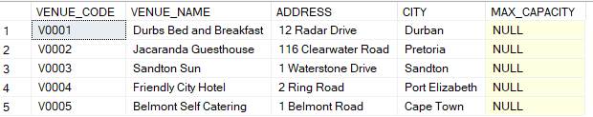

UPDATE VENUES

SET MAX_CAPACITY ='2'

WHERE VENUE_CODE='V0001';

UPDATE VENUES

SET MAX_CAPACITY ='6'

WHERE VENUE_CODE='V0002';

UPDATE VENUES

SET MAX_CAPACITY ='4'

WHERE VENUE_CODE='V0003';

UPDATE VENUES

SET MAX_CAPACITY ='4'

WHERE VENUE_CODE='V0004';

UPDATE VENUES

SET MAX_CAPACITY ='10'

WHERE VENUE_CODE='V0005';

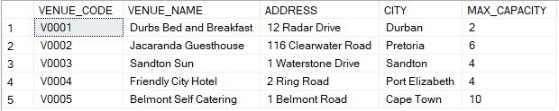

SELECT CUSTOMERS.CUSTOMER_ID, CUSTOMERS.CUSTOMER_NAME

FROM CUSTOMERS

LEFT JOIN ACCOMMODATION_BOOKINGS ON CUSTOMERS.CUSTOMER_ID = ACCOMMODATION_BOOKINGS.CUSTOMER_ID

WHERE ACCOMMODATION_BOOKINGS.CUSTOMER_ID IS NULL;



SELECT CUSTOMERS.CUSTOMER_ID, CUSTOMERS.CUSTOMER_NAME, COUNT(ACCOMMODATION_BOOKINGS.CUSTOMER_ID) AS BOOKED_ACCOMMODATIONS

FROM CUSTOMERS

LEFT JOIN ACCOMMODATION_BOOKINGS ON CUSTOMERS.CUSTOMER_ID = ACCOMMODATION_BOOKINGS.CUSTOMER_ID

GROUP BY CUSTOMERS.CUSTOMER_ID, CUSTOMERS.CUSTOMER_NAME

ORDER BY BOOKED_ACCOMMODATIONS DESC;

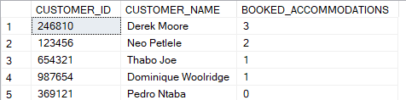

SELECT CUSTOMERS.CUSTOMER_ID, CUSTOMERS.CUSTOMER_NAME, ACCOMMODATION_BOOKINGS.CHECKIN_DATE, ACCOMMODATION_BOOKINGS.NIGHTS

FROM CUSTOMERS

JOIN ACCOMMODATION_BOOKINGS ON CUSTOMERS.CUSTOMER_ID = ACCOMMODATION_BOOKINGS.CUSTOMER_ID

WHERE ACCOMMODATION_BOOKINGS.NIGHTS = (

SELECT MAX(NIGHTS)

FROM ACCOMMODATION_BOOKINGS

);

